## **Model conceptual**

## 

Model Logic

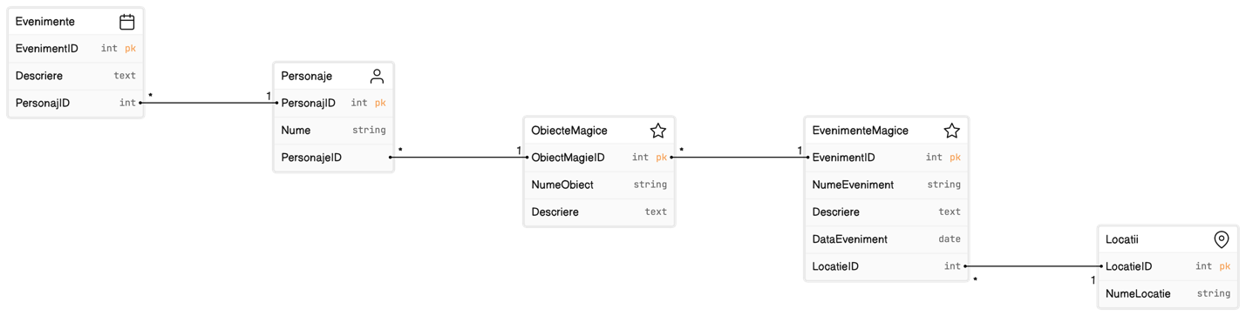

## 

## **Extragere date**

SELECT * FROM Locatii ORDER BY NumeLocatie ASC;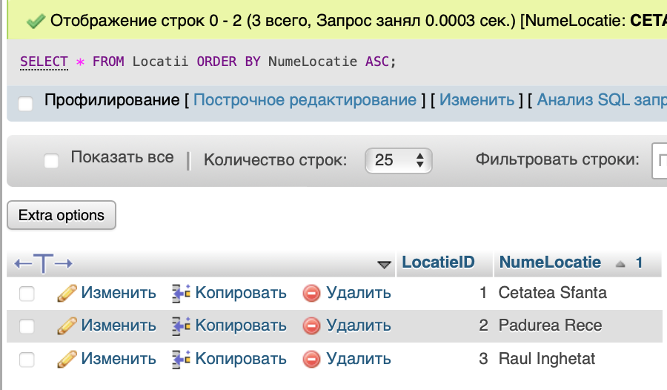

## SELECT NumeObiect, Descriere FROM ObiecteMagice;

## 

## **Actualizare date**

## 

## **Select IF True**

## SELECT EvenimentID, NumeEveniment, Descriere, DataEveniment, LocatieID, IF(LocatieID = 1, 'Cetatea Sfanta', IF(LocatieID = 2, 'Padurea Rece', IF(LocatieID = 3, 'Raul Inghetat', 'Locatie necunoscuta'))) AS NumeLocatie FROM EvenimenteMagice;

## 

## **2.2 Elaborarea pasilor din SQL for Beginners:**

CREATE DATABASE my_first_db;



USE my_first_db;



CREATE TABLE users (

    username VARCHAR(20),

    create_date DATE

);

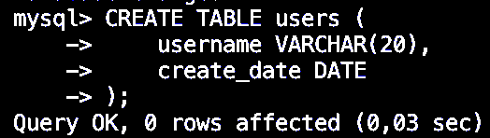

CREATE TABLE users (

user_id INT AUTO_INCREMENT PRIMARY KEY,

username VARCHAR(20),

create_date DATE

);



Show tables;

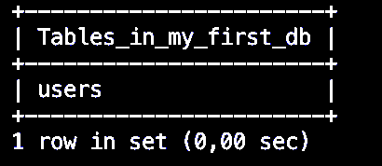

Explain users;

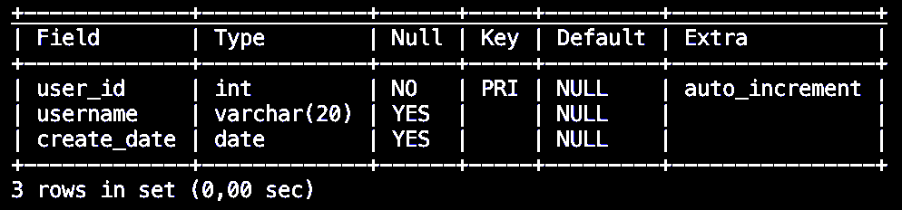

ALTER TABLE users

ADD email VARCHAR(100)

AFTER username;

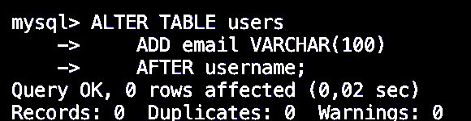

EXPLAIN users;

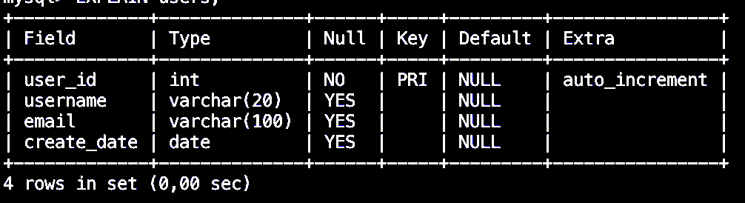

ALTER TABLE users DROP email;



ALTER TABLE users

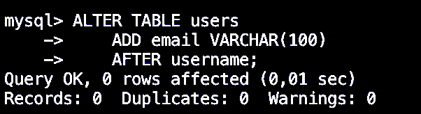

ALTER TABLE users

CHANGE username

user_name VARCHAR(30);



INSERT INTO users VALUES (

NULL,

'johndoe',

'john@doe.com',

'2009-12-14'

);

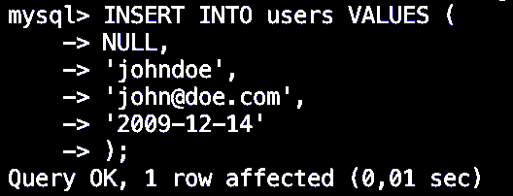

INSERT INTO users SET

User_name = 'nettuts',

Email = 'nettuts@gmail.com',

Create_date = '2009-12-15';

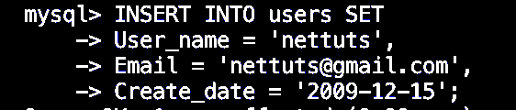

SELECT NOW();

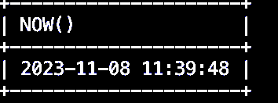

SELECT * from users;

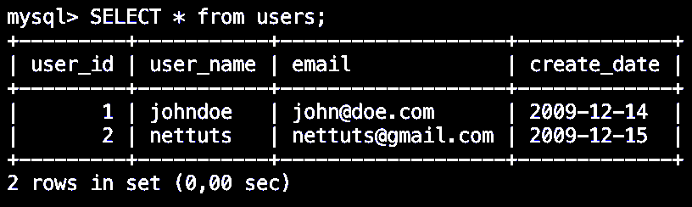

SELECT * FROM users

ORDER BY create_date;

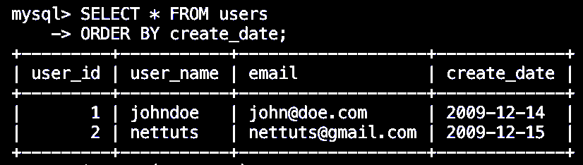

UPDATE users SET

Email = 'changed@gmail.com',

User_name = 'foobar'

WHERE User_name = 'johndoe';

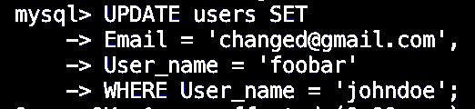

INSERT INTO users SET user_name = 'O''Reilly';



CREATE TABLE states (

id INT AUTO_INCREMENT,

name VARCHAR(20),

join_year INT,

population INT,

PRIMARY KEY (id),

UNIQUE (name),

KEY (join_year)

);

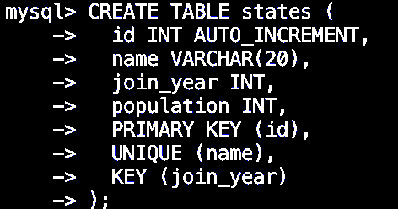

INSERT INTO states VALUES

(1, 'Alabama', 1819, 4661900),

(2, 'Alaska', 1959, 686293),

(3, 'Arizona', 1912, 6500180),

(4, 'Arkansas', 1836, 2855390),

(5, 'California', 1850, 36756666),

(6, 'Colorado', 1876, 4939456),

(7, 'Connecticut', 1788, 3501252),

(8, 'Delaware', 1787, 873092),

(9, 'Florida', 1845, 18328340),

(10, 'Georgia', 1788, 9685744),

(11, 'Hawaii', 1959, 1288198),

(12, 'Idaho', 1890, 1523816),

(13, 'Illinois', 1818, 12901563),

(14, 'Indiana', 1816, 6376792),

(15, 'Iowa', 1846, 3002555),

(16, 'Kansas', 1861, 2802134),

(17, 'Kentucky', 1792, 4269245),

(18, 'Louisiana', 1812, 4410796),

(19, 'Maine', 1820, 1316456),

(20, 'Maryland', 1788, 5633597),

(21, 'Massachusetts', 1788, 6497967),

(22, 'Michigan', 1837, 10003422),

(23, 'Minnesota', 1858, 5220393),

(24, 'Mississippi', 1817, 2938618),

(25, 'Missouri', 1821, 5911605),

(26, 'Montana', 1889, 967440),

(27, 'Nebraska', 1867, 1783432),

(28, 'Nevada', 1864, 2600167),

(29, 'New Hampshire', 1788, 1315809),

(30, 'New Jersey', 1787, 8682661),

(31, 'New Mexico', 1912, 1984356),

(32, 'New York', 1788, 19490297),

(33, 'North Carolina', 1789, 9222414),

(34, 'North Dakota', 1889, 641481),

(35, 'Ohio', 1803, 11485910),

(36, 'Oklahoma', 1907, 3642361),

(37, 'Oregon', 1859, 3790060),

(38, 'Pennsylvania', 1787, 12448279),

(39, 'Rhode Island', 1790, 1050788),

(40, 'South Carolina', 1788, 4479800),

(41, 'South Dakota', 1889, 804194),

(42, 'Tennessee', 1796, 6214888),

(43, 'Texas', 1845, 24326974),

(44, 'Utah', 1896, 2736424),

(45, 'Vermont', 1791, 621270),

(46, 'Virginia', 1788, 7769089),

(47, 'Washington', 1889, 6549224),

(48, 'West Virginia', 1863, 1814468),

(49, 'Wisconsin', 1848, 5627967),

(50, 'Wyoming', 1890, 532668);

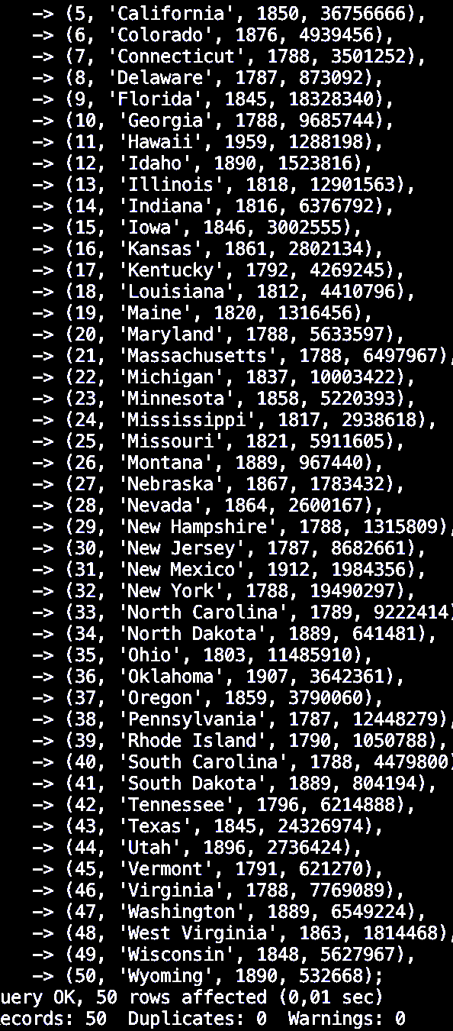

Select * from states where join_year = 1787;

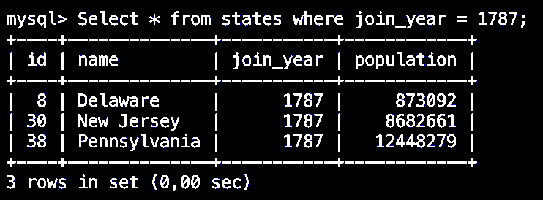

SELECT COUNT(*), join_year FROM states GROUP BY join_year;

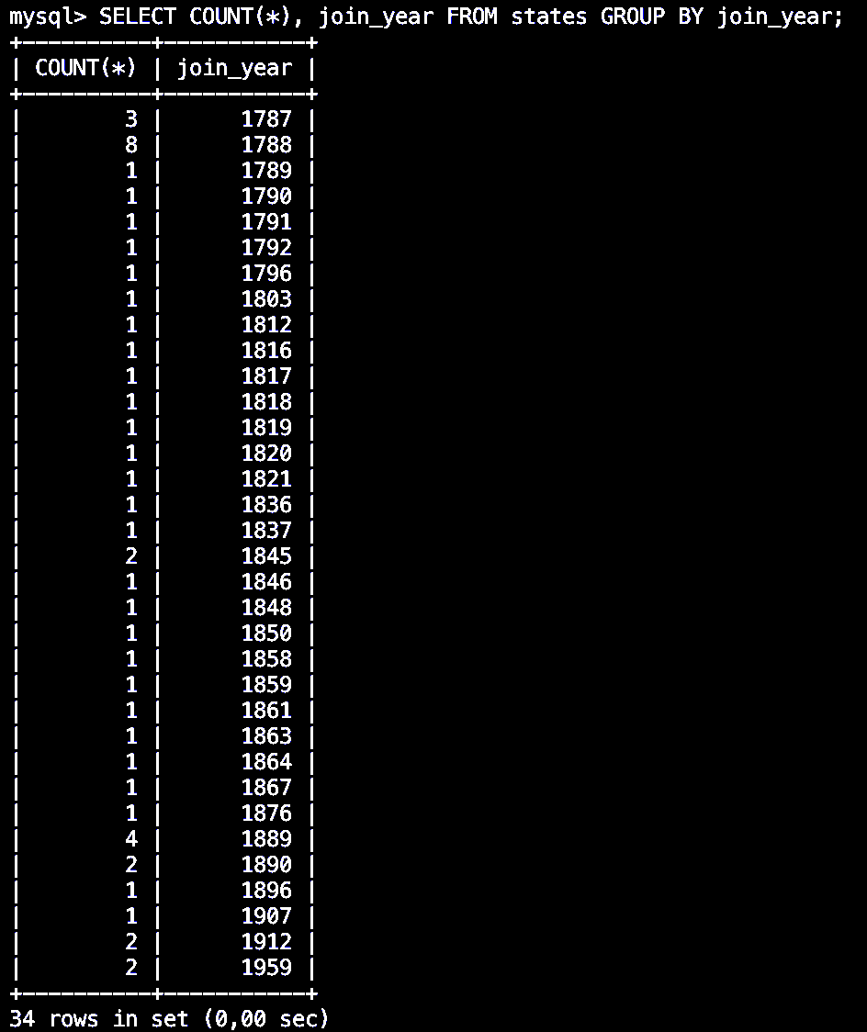

SELECT COUNT(*) FROM states;

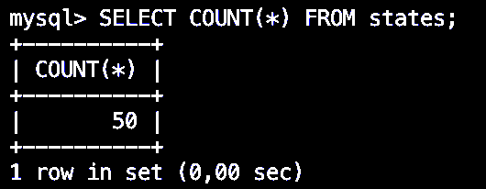

Select count(*) from states where join_year = 1787;

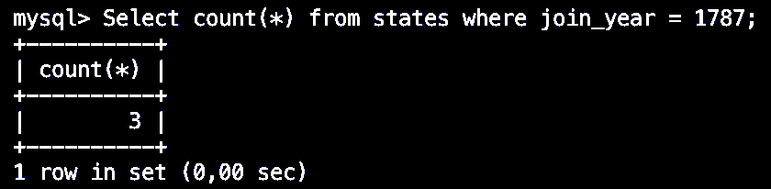

SELECT MIN(population), MAX(population), AVG(population) from states;

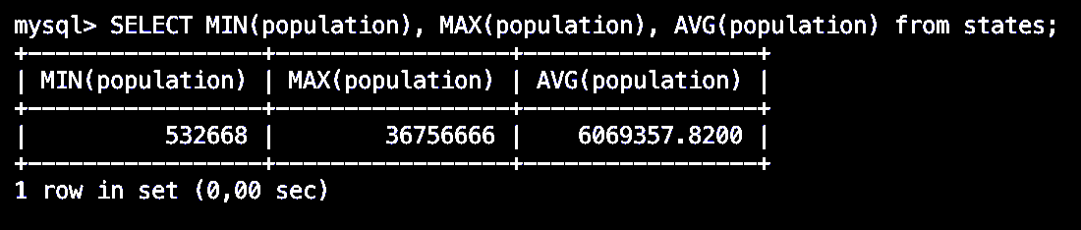

SELECT GROUP_CONCAT(name SEPARATOR ', '), join_year

FROM states GROUP BY join_year;

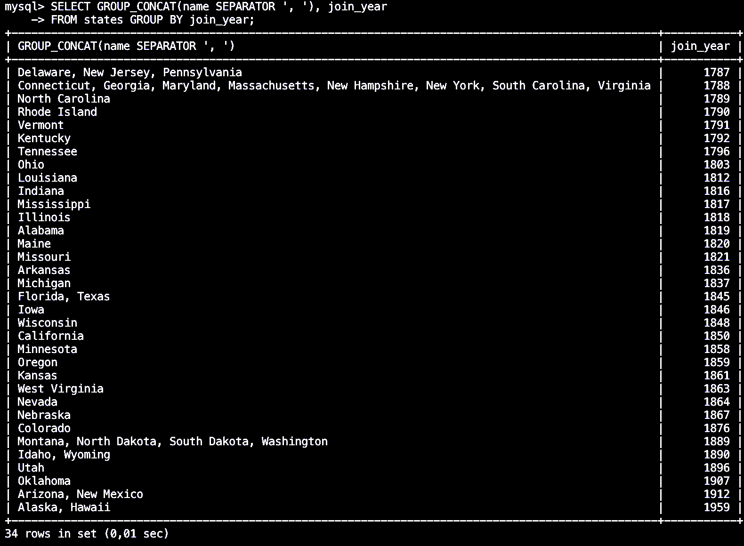

SELECT SUM(population) as usa_population from states;

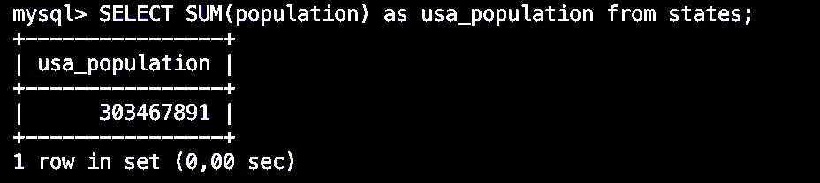

SELECT

SUM(

IF(population > 5000000, 1, 0)

) AS big_states,

SUM(

IF(population <= 5000000, 1, 0)

) AS small_states

FROM states;

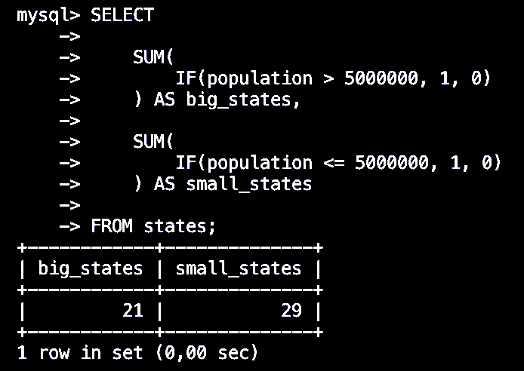

SELECT

COUNT(*),

CASE

WHEN population > 5000000 THEN 'big'

WHEN population > 1000000 THEN 'medium'

ELSE 'small' END

AS state_size

FROM states GROUP BY state_size;

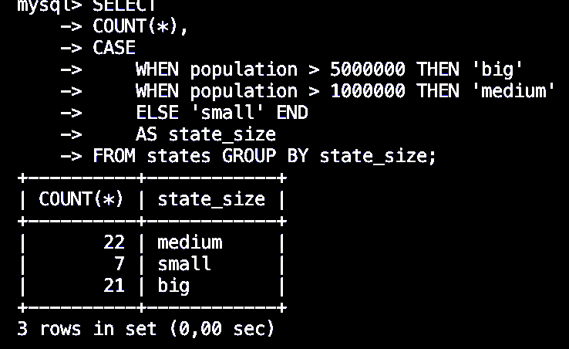

SELECT COUNT(*), join_year FROM states GROUP BY join_year;

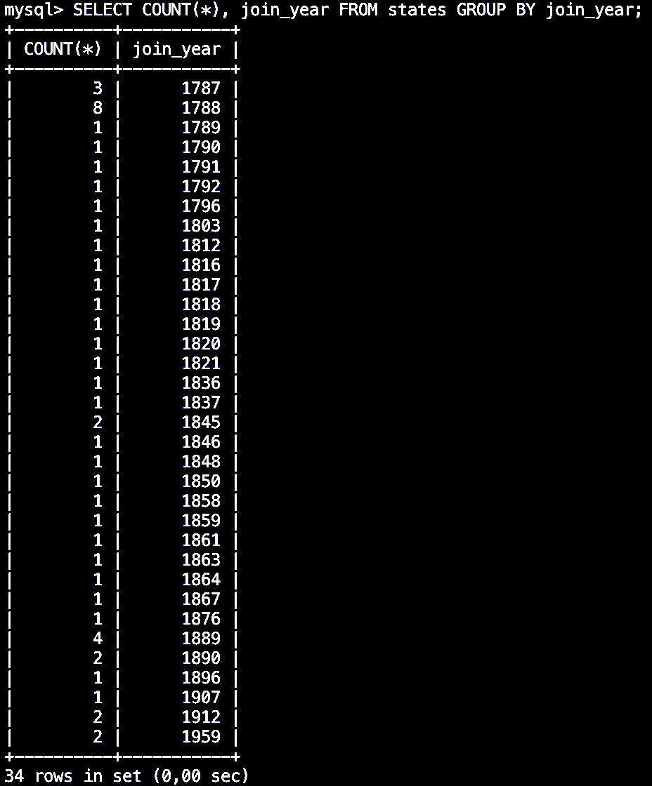

SELECT * FROM states WHERE population = (

SELECT MAX(population) FROM states

);

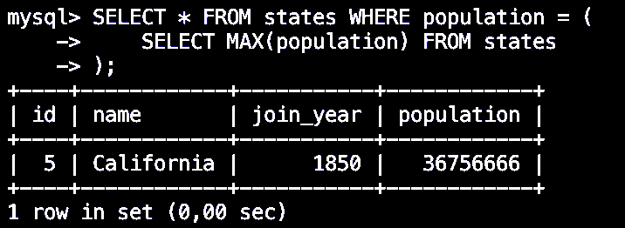

SELECT * FROM states WHERE join_year = (

SELECT MAX(join_year) FROM states

);

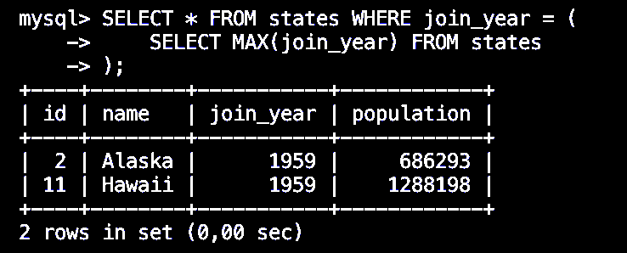

SELECT * FROM states WHERE join_year IN (

SELECT join_year FROM states

GROUP BY join_year

HAVING COUNT(*) > 1

) ORDER BY join_year;

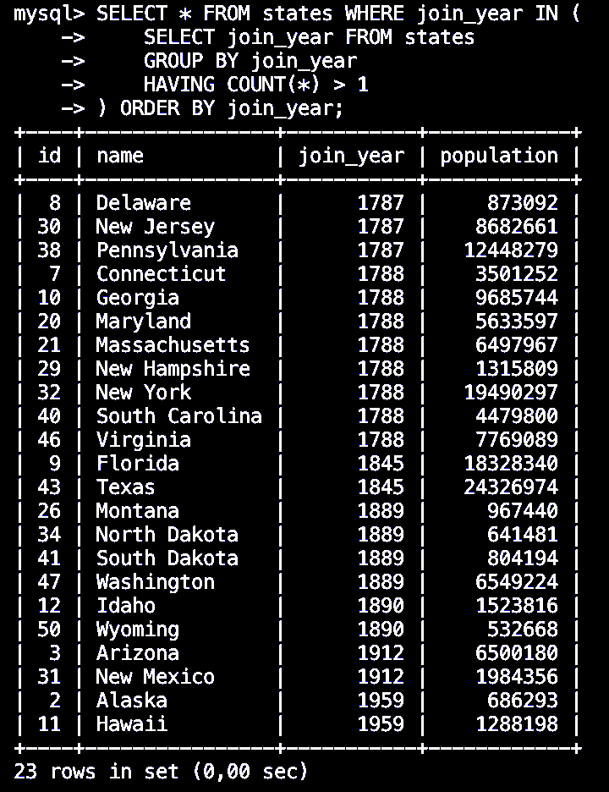

(SELECT * FROM states WHERE name LIKE 'n%')

UNION

(SELECT * FROM states WHERE population > 10000000);

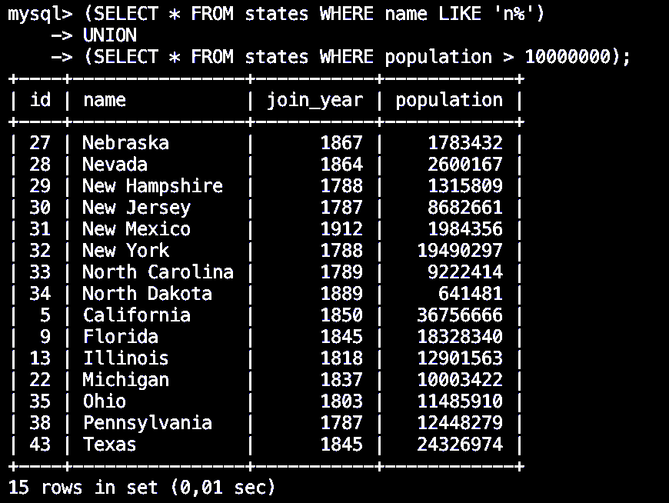

CREATE TABLE customers (

customer_id INT AUTO_INCREMENT PRIMARY KEY,

customer_name VARCHAR(100)

);

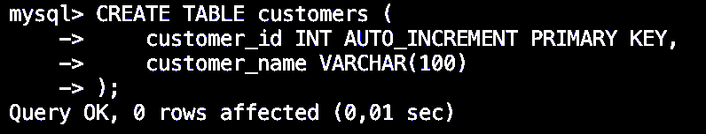

CREATE TABLE orders (

order_id INT AUTO_INCREMENT PRIMARY KEY,

customer_id INT,

amount DOUBLE,

FOREIGN KEY (customer_id) REFERENCES customers(customer_id)

);

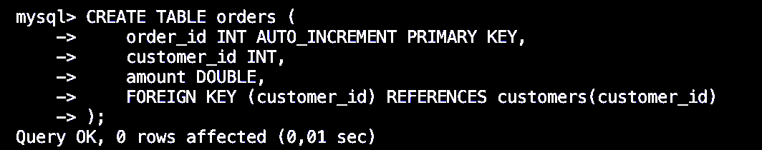

INSERT INTO `customers` (`customer_id`, `customer_name`) VALUES

(1, 'Adam'),

(2, 'Andy'),

(3, 'Joe'),

(4, 'Sandy');

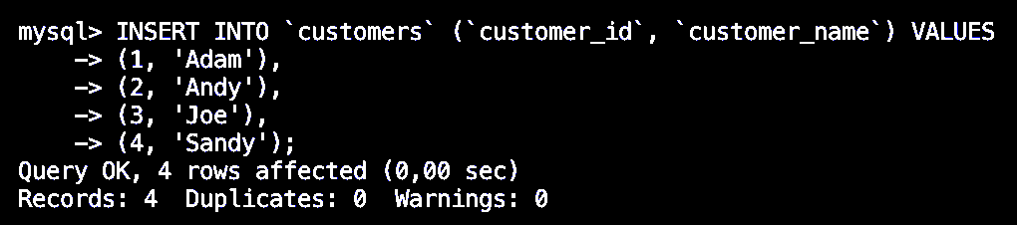

INSERT INTO `orders` (`order_id`, `customer_id`, `amount`) VALUES

(1, 1, 19.99),

(2, 1, 35.15),

(3, 3, 17.56),

(4, 4, 12.34);

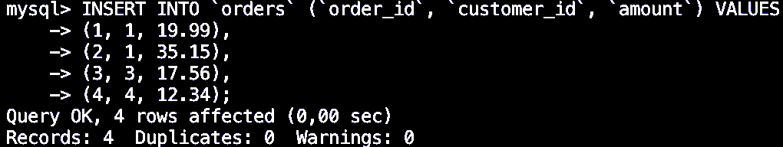

SELECT * FROM customers, orders;

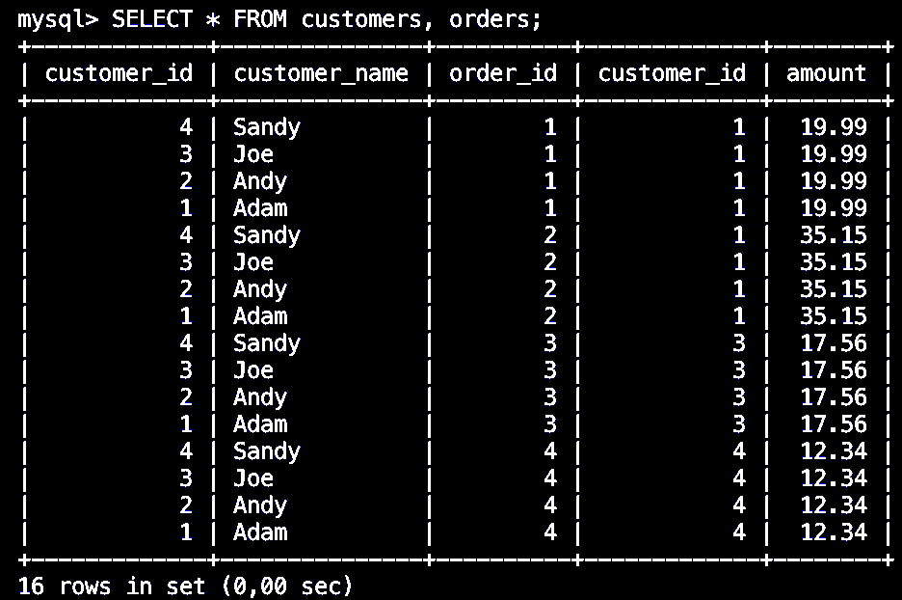

SELECT * from customers NATURAL JOIN orders;

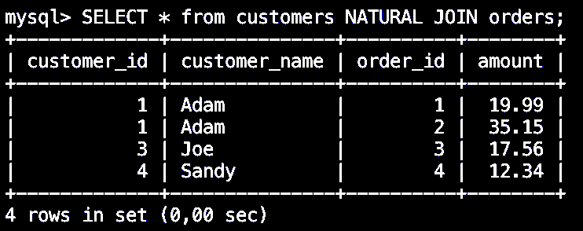

SELECT * FROM customers JOIN orders

WHERE customers.customer_id = orders.customer_id;

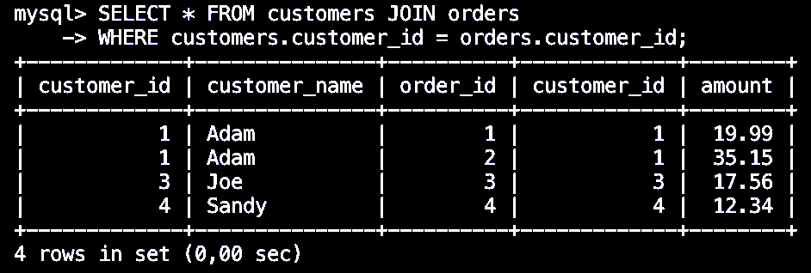

SELECT * FROM customers JOIN orders

USING (customer_id)

WHERE orders.amount > 15;

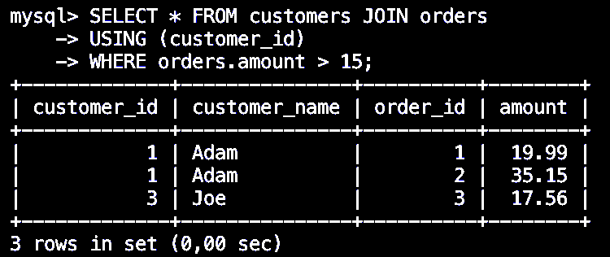

SELECT * FROM customers LEFT OUTER JOIN orders

USING (customer_id);

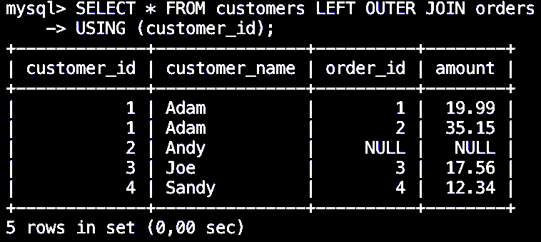

SELECT * FROM customers RIGHT OUTER JOIN orders

USING (customer_id);

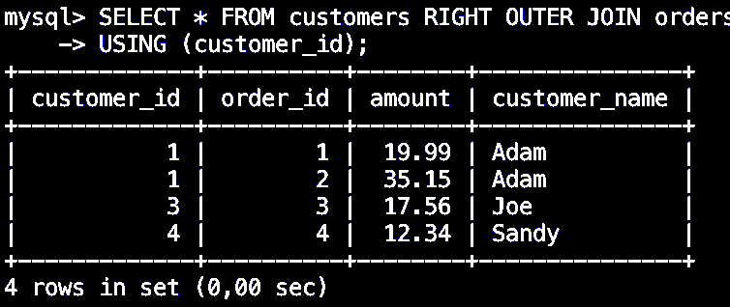

SELECT * FROM orders RIGHT OUTER JOIN customers

USING (customer_id);

USING (customer_id);

